Contents

Introduction 1

Literature Review: 1

What is Xamrine? 1

Who Xamrine is for? 1

How xamrine works? 2

What is Agile SDLC? 2

Tools and Technology Requirement: 2

Modules of the Application: 3

Sequence Diagram: 4

Working of the Expense App: 7

Group Tasks: 8

Robin sharma 8

Atul Atul 8

Navjot singh 8

paarth adlakha 8

Bikramjit singh 8

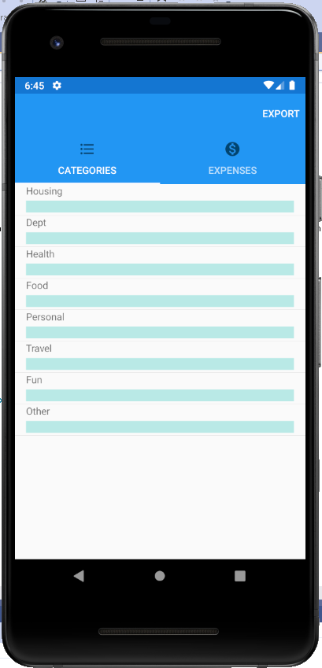

Expense App

Agile Project Report

Name | Course Title | Date

# Introduction

As the name itself suggests, this project is an attempt to manage our daily expenses in a more efficient and manageable way. Sometime we can’t remember where our money goes. And we can’t handle our cash flow.

For this problem, we need a solution that everyone can manage their expenses. So, we decided to find an easier way to get rid of this problem. So, our application attempts to free the user with as much as possible the burden of manual calculation and to keep the track of the expenditure.

Instead of keeping a diary or a log of the expenses, this application enables the user to not just keep the control on the expenses but also to generate and save reports. With the help of this application, the user can manage their expenses on a daily, weekly and monthly basis. Users can insert and delete transactions as well as can generate and save their reports.

The graphical representation of the application is the main part of the system as it appeals to the user more and is easy to understand.

# Literature Review:

## What is Xamrine?

Xamarin is an open-source platform for building modern and performant applications for iOS, Android, and Windows with .NET. Xamarin is an abstraction layer that manages communication of shared code with underlying platform code. Xamarin runs in a managed environment that provides conveniences such as memory allocation and garbage collection.

Xamarin enables developers to share an average of 90% of their application across platforms. This pattern allows developers to write all of their business logic in a single language (or reuse existing application code) but achieve native performance, look, and feel on each platform.

Xamarin applications can be written on PC or Mac and compile into native application packages, such as an **.apk** file on Android, or an **.ipa** file on iOS.

## Who Xamrine is for?

Xamarin is for developers with the following goals:

* Share code, test and business logic across platforms.
* Write cross-platform applications in C# with Visual Studio.

## How xamrine works?

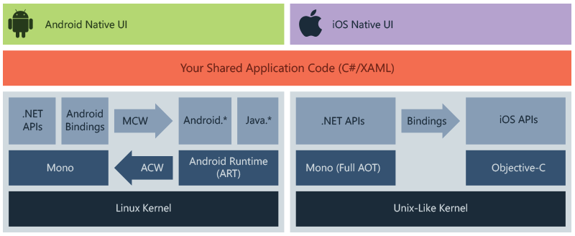

The diagram shows the overall architecture of a cross-platform Xamarin application. Xamarin allows you to create native UI on each platform and write business logic in C# that is shared across platforms. In most cases, 80% of application code is sharable using Xamarin.

Xamarin is built on top of .NET, which automatically handles tasks such as memory allocation, garbage collection and interoperability with underlying platforms.

## What is Agile SDLC?

Agile SDLC model is a combination of iterative and incremental process models with focus on process adaptability and customer satisfaction by rapid delivery of working software product. Agile Methods break the product into small incremental builds. These builds are provided in iterations.

# Tools and Technology Requirement:

**Hardware**

**Processor**

Intel ® Core™ i3-2370 CPU @2.40GHz

**Installed Memory (RAM)**

1.00 GB or above

**System Type**

Android 4.4 Kitkat or above.

IOS 9 above

**Software Interface**

Client-Side

Android Mobile

**Software**

Xamarin

# Modules of the Application:

The modules which are currently covered are:

**Add income/add expense**

This module deals with adding income and expenses. The user has both options available for adding income and expense. But there is a condition if the user hasn’t entered the amount yet then the user can’t enter expenses. When the user enters any transaction then that transaction will be added in both Spending and Transaction tabs. If the user wants to delete that transaction then the user has to long click the transaction available in the spending tab then that transaction will be deleted from both tabs.

**Modify Transactions**

If the user wants to delete that transaction then the user has to click the transaction available in the spending tab then that transaction will be deleted from both tabs.

**Filter Transaction view**

In the transaction tab, the user can filter the transactions. In the Spinner, users can select the day, month and year and then click the filter button and according to the day, month and year transactions will appear. If the user wants to filter the transactions only on the basis of day, for example, user-selected Monday then all transactions will appear that were made on Monday.

**PDF Report**

In the transaction, the tab user has an option available for creating a report in PDF. Users click on the PDF button then PDF report will be generated and the user can view that report and that report will be automatically saved in the device.

**Multiple Accounts**

Users can create multiple accounts. In the account tab. User has the option available for creating a new account.  Users will click the “+” sign button then a dialog will appear on the screen and the user can enter the name of the account then that name will be saved in the account tab. If a user wants to delete the particular account then the user has to l click the account name user want to delete. Then that account will be deleted.

# Sequence Diagram:

The sequence diagram for the application is stated as follows:

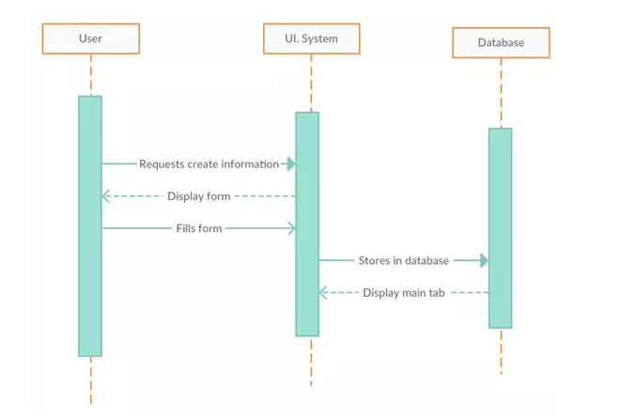

Figure 1 User interacting with the system and system with the database

User is now creating information inside the application selecting the option for the expense to be added which will then displays the form to be filled to add the expense. And store the expense in the database that then can be displayed when needed.

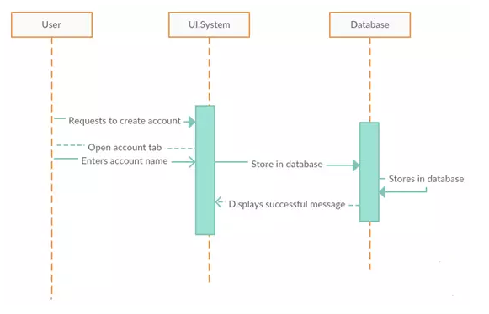

Figure 2 User accessing the database using the system

The above stated sequence diagram shows that how a new user can create account in the expense calculator application for the sake of calculation of the basic expense.

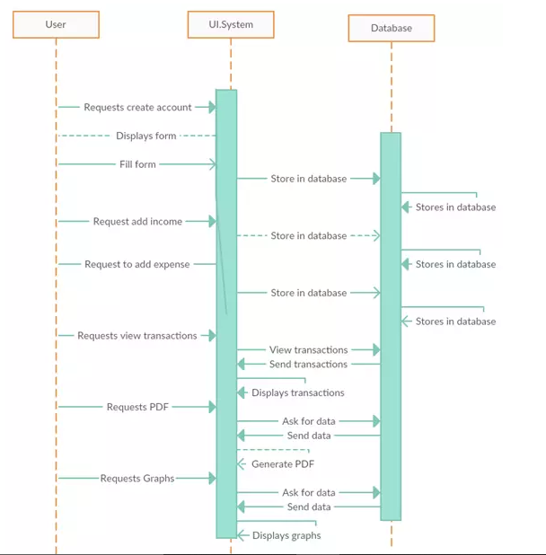

Figure 3 Basic functionalities of the system

The above stated picture shows that how transactions will flow in the expense app and how the records will be displayed and how pdf of the records can be generated.

# Working of the Expense App:

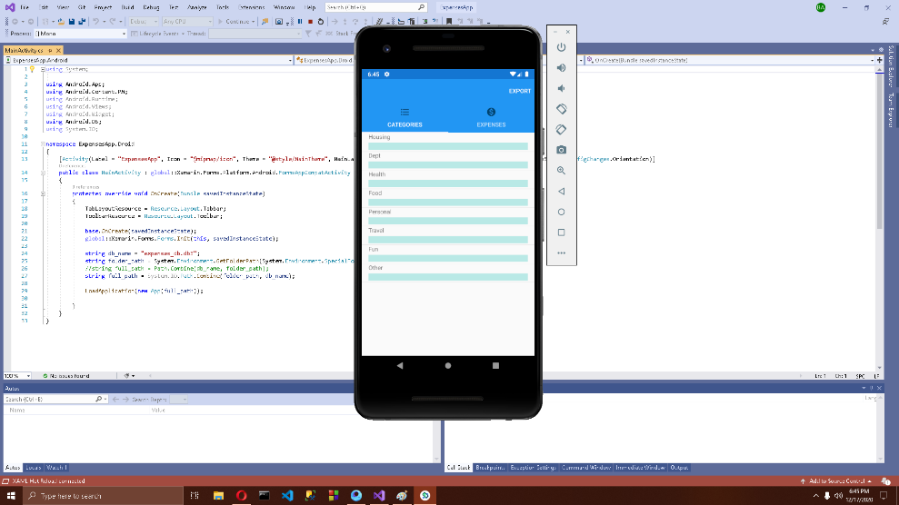

Figure 4 Expense App

The working of the Expense app is very simple a menu of expenses is given in the main menu where the user can choose between different types of expenses to be added in the expense app. These Expense list includes the housing expense, Health, food, personal and many more options are available.

The second basic button in the main menu is the expense button here we can see the list of expense and total expense with date.

The third thing in this application is the export button from where we can export pdf of the expense list created through the application.

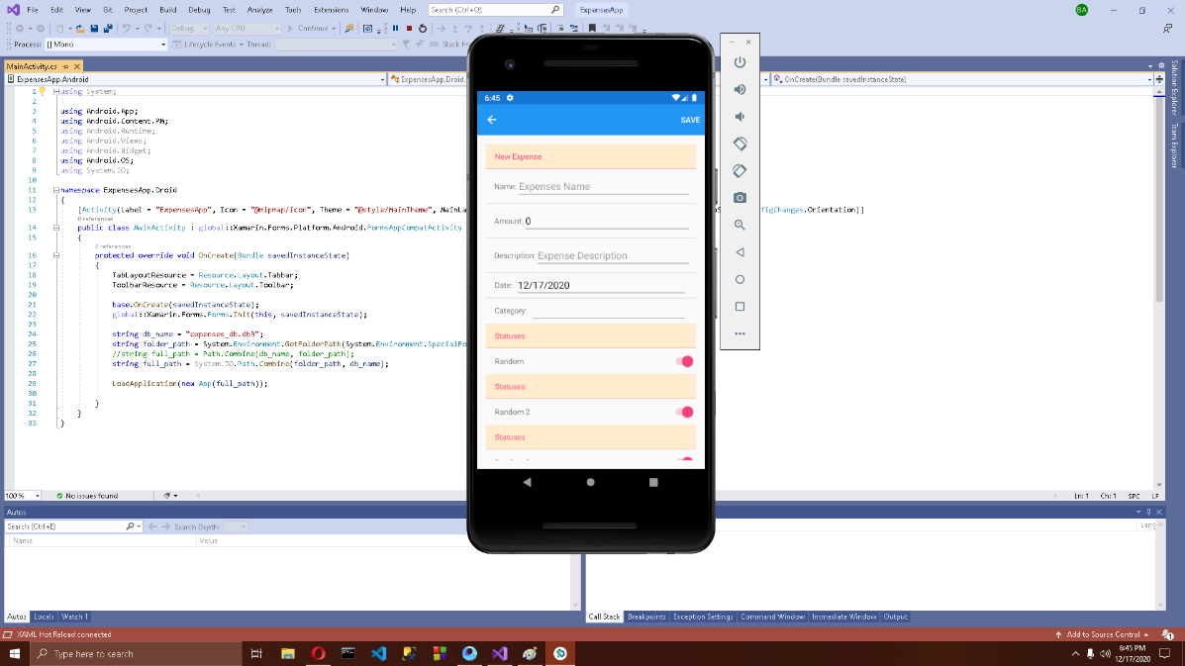

Figure 5 Form for the expense is being filled

# Group Tasks:

## Robin sharma

Robin Sharma has done the designing of the application interface and the functionality to add the expenses using the application and designed the add expense form.

## Atul Atul

Atul has implemented the functionality of food and house expense in the application and helped the student 1 in designing the application interface.

## Navjot singh

Navjot Singh has implemented the Travel, Fun and Personal expense and designed their request forms.

## paarth adlakha

Paarth Adlakha has helped the student 3 in finalizing all the methodology with effective calculation expenses in the expense button of the application.

## Bikramjit singh

Bikramjit Singh has implemented the export button form where we can generate a pdf of the monthly expense.